**Pengujian Testing WhiteBox oleh:**

**Candra Billy Sagita | TI.17.D4**

1. Testing Whitebox OpenEducat_Activity
   1. Source Code test_activity_common.py

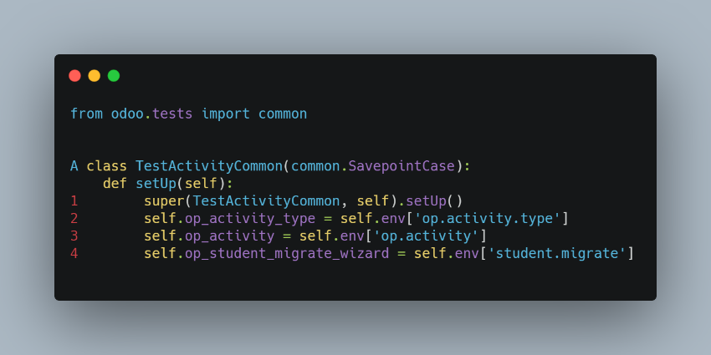

Source Code test_activity.py

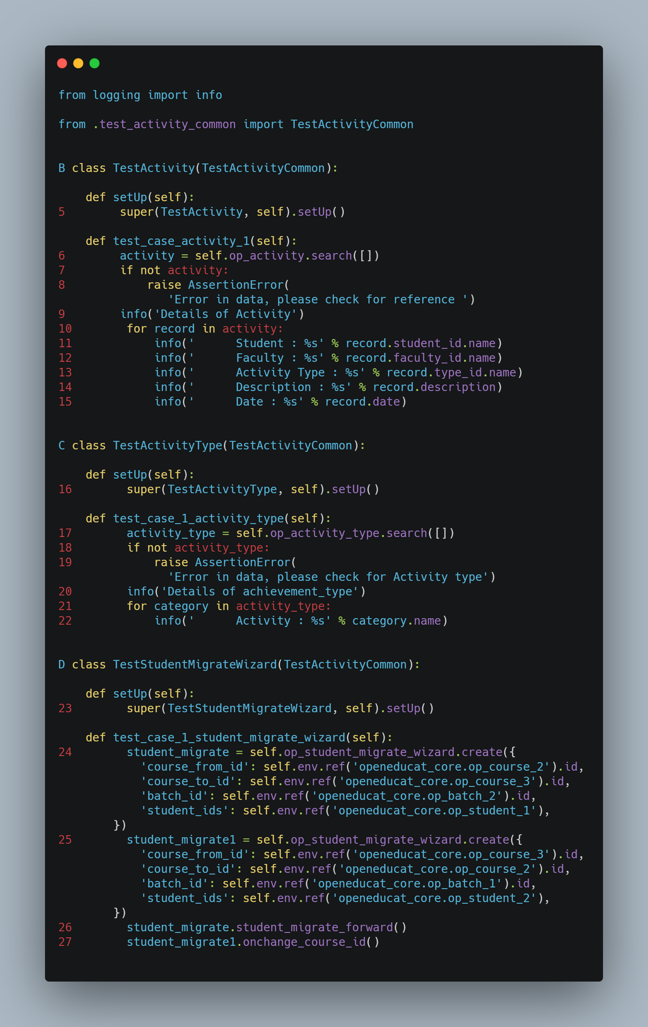

* 1. Flowgraph

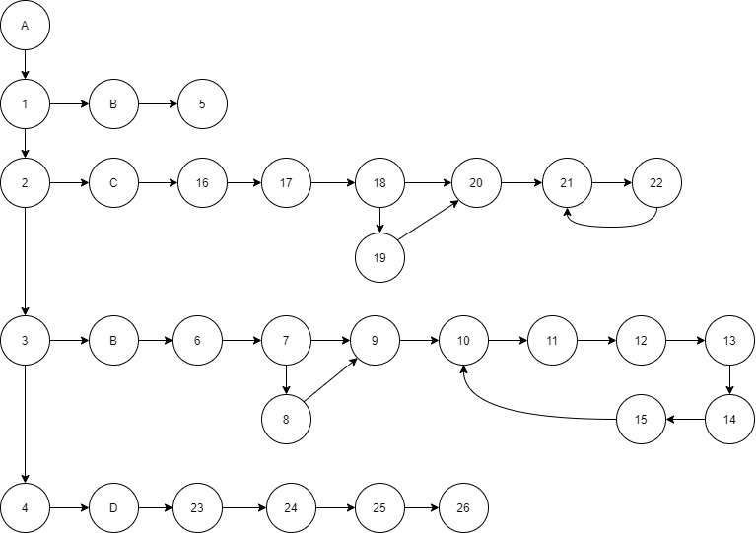

* 1. Cyclometic Complexity

V (G) = E - N + 2

= 34 - 26 + 2

= 10

* 1. Test Case

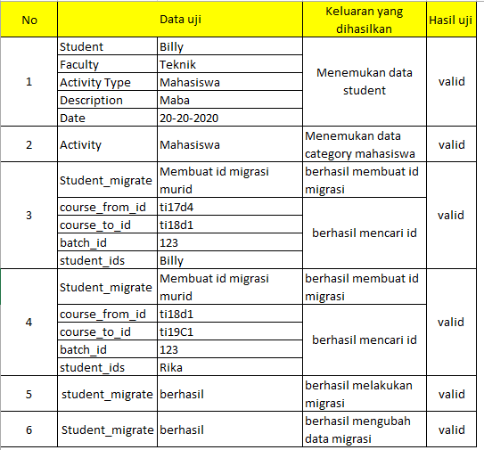

1. Testing WhiteBox OpenEducat_admission
   1. Source Code test_admission_common.py

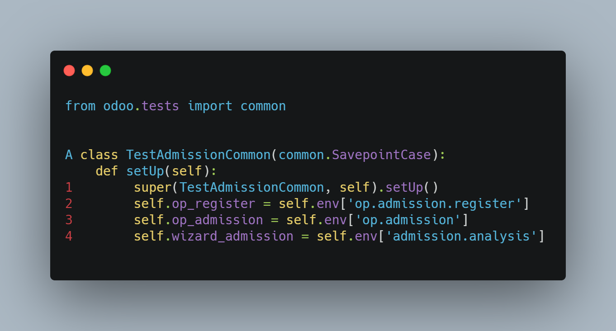

Source Code test_admission.py

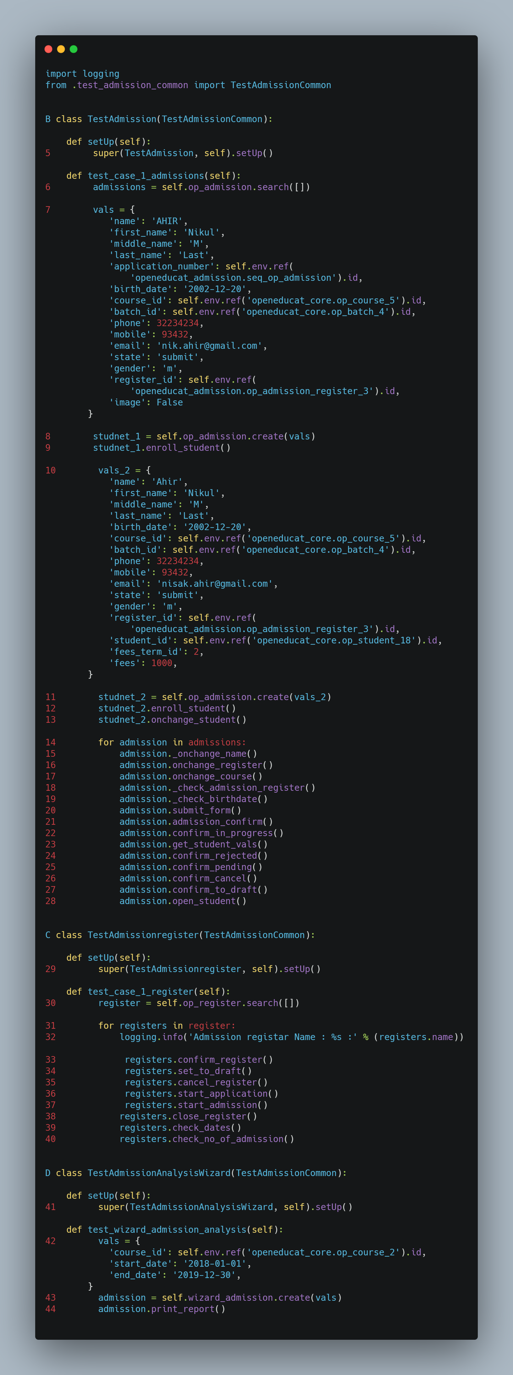

* 1. Flowgraph

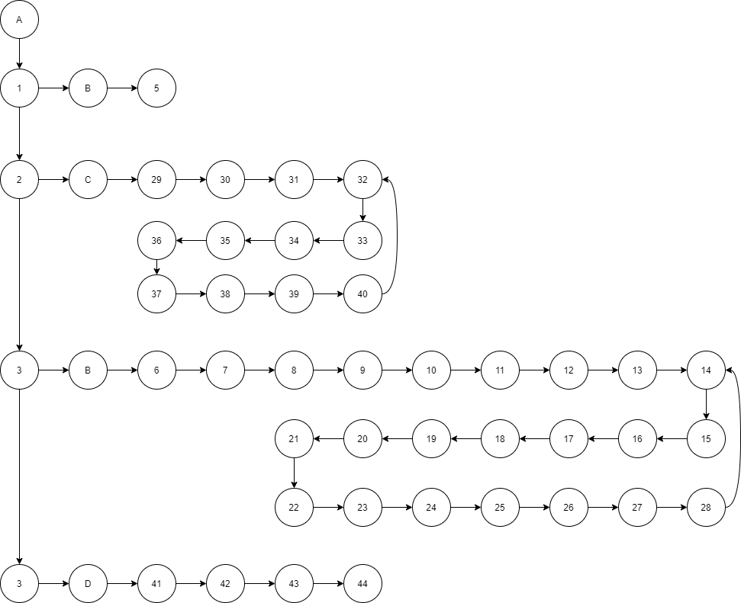

* 1. Cyclometic Complexity

V (G) = E - N + 2

= 50 - 44 + 2

= 8

* 1. Test Case

|  |  |  |  |
| --- | --- | --- | --- |
| No | Data uji | Keluaran yang diharapkan | Hasil uji |
| 1 |  |  |  |
| 2 |  |  |  |
| 3 |  |  |  |
| 4 |  |  |  |
| 5 |  |  |  |
| 6 |  |  |  |
| 7 |  |  |  |

1. Testing WhiteBox OpenEducat_facility
   1. Source Code test_facility_common.py

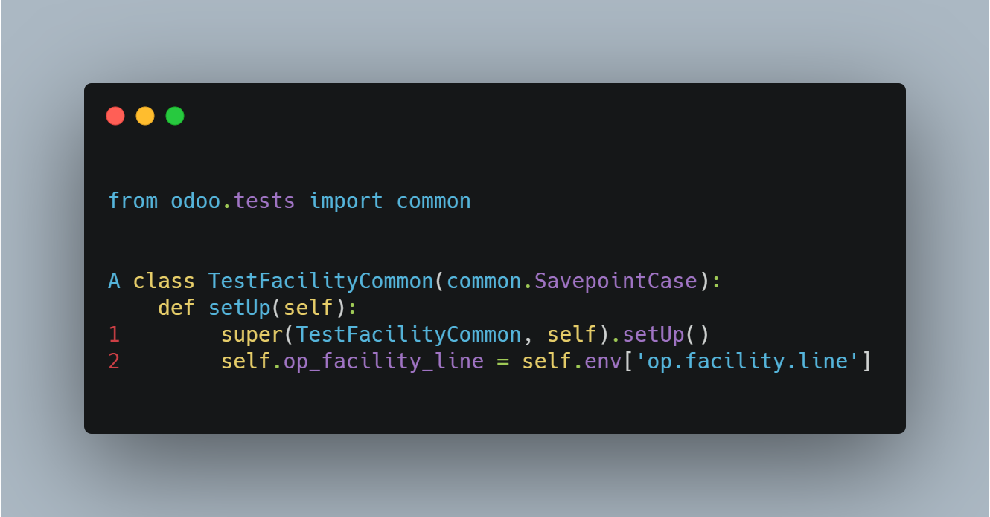

Source Code test_facility.py

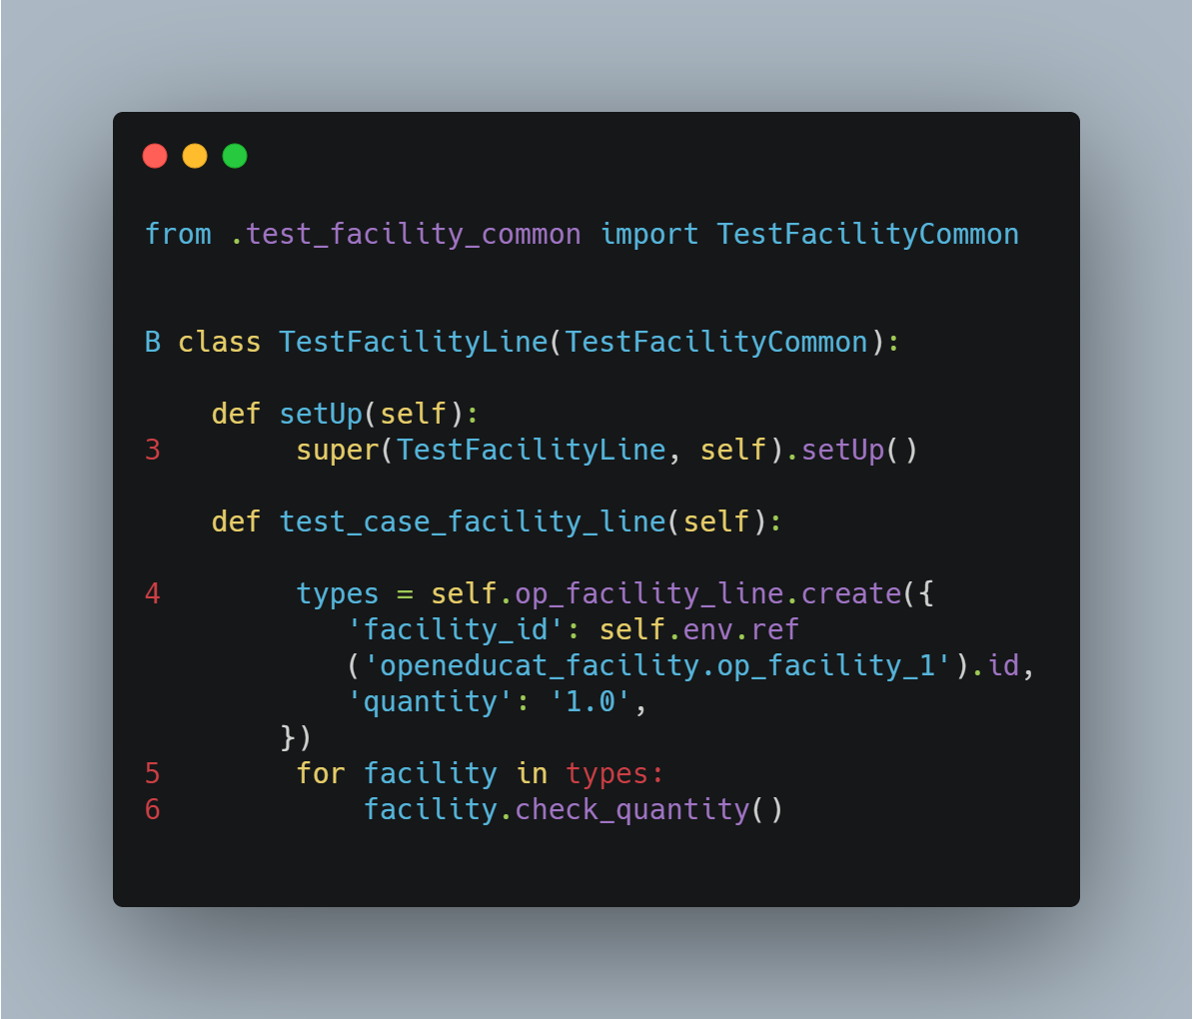

* 1. Flowgraph

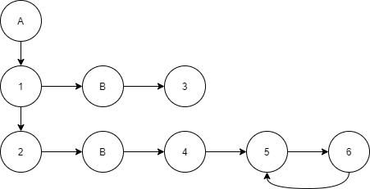

* 1. Cyclometic Complexity

V (G) = E - N + 2

= 9 – 6 + 2

= 5